CHECK OUT LAKE TAHOE

Straddling the border of California and Nevada, Lake Tahoe is the largest alpine lake in North America. It’s also a fantastic travel destination for outdoor adventure.

(MARKET IMAGE HERE)

Find Deals From These Cities

INSERT FARE GRID FROM / TO Version (if available!)

   
Top Things To Do in Lake Tahoe

When visiting Lake Tahoe, you’ll have the opportunity to do it all–swimming, skiing, shopping, dining, and more. Below are some of the top things to do while you’re there.

* Winter sports lovers won’t know where to start in Lake Tahoe. There are more than 22,000 acres for ski and snowboard adventure within the six resorts: Squaw Valley, Heavenly, Sierra, Mt. Rose, Kirkwood and Northstar.
* To truly experience Lake Tahoe’s beauty, a trip to Emerald Bay State Park is a must. Known for its breathtaking scenery, you’ll get some of the most amazing photos here. If you’re feeling really adventurous, go scuba diving in the Underwater Park.
* Visit the magical mountain town of Truckee. This old railroad town is full of culture and offers a ton of great shopping, dining and entertainment.
* Have a picnic at Sand Harbor State Park while attending a performance during the Lake Tahoe Shakespeare Festival in July and August.

Travel Tips and Resources

[Must-Dos in Lake Tahoehttp://www.tripadvisor.com/Attractions-g155987-Activities-Lake_Tahoe_California_California.html](http://www.tripadvisor.com/Attractions-g155987-Activities-Lake_Tahoe_California_California.html)

[Lake Tahoe Hotelshttp://www.tripadvisor.com/Hotels-g155987-Lake_Tahoe_California_California-Hotels.html](http://www.tripadvisor.com/Hotels-g155987-Lake_Tahoe_California_California-Hotels.html)

[Lake Tahoe Restaurantshttp://www.tripadvisor.com/Restaurants-g155987-Lake_Tahoe_California_California.html](http://www.tripadvisor.com/Restaurants-g155987-Lake_Tahoe_California_California.html)

[Lake Tahoe Shopping Guidehttp://www.tripadvisor.com/Attractions-g155987-Activities-c26-Lake_Tahoe_California_California.html](http://www.tripadvisor.com/Attractions-g155987-Activities-c26-Lake_Tahoe_California_California.html)

[Lake Tahoe Nightlife and Entertainmenthttp://www.tahoeactivities.com/lake-tahoe-nightlife](http://www.tahoeactivities.com/lake-tahoe-nightlife)

[Lake Tahoe Travel Tipshttp://travel.usnews.com/Lake_Tahoe_CA/Travel_Tips](http://travel.usnews.com/Lake_Tahoe_CA/Travel_Tips)

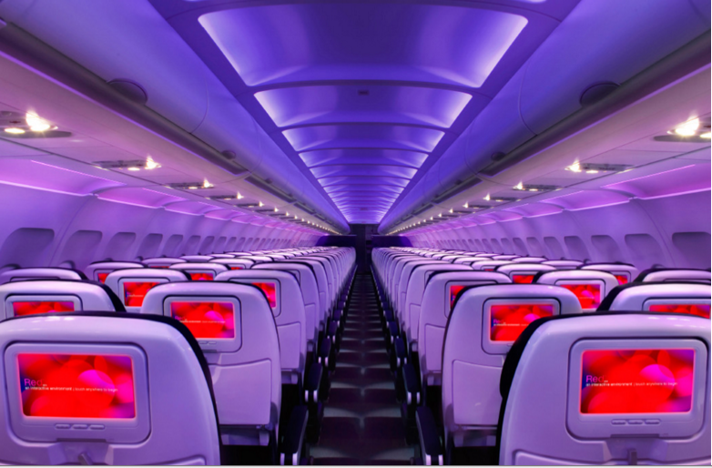

Main Cabin Main Cabin Select First Class

(add links to Cabin Class Pages)

Ready. Set. Fly.

Book your Mood-lit Ride to Lake Tahoe.

Book a direct flight to San Francisco International with Virgin America. Once in San Francisco, if your schedule allows, you can enjoy some of the sights or great food this city has to offer before enjoying the scenic drive to Lake Tahoe via car or public transportation. After flying with us and experiencing the ultimate in airline comfort and convenience, you’ll be relaxed and ready to enjoy your time in Northern California

Take a Virtual Tour

Add Terms & Conditions